**Low Level Design (LLD)**

**PRESCRIPTION LABEL READING**

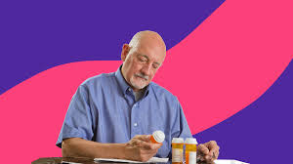

**Revision Number - 1.0**

**Last Date of Revision – 16-11-2023**

**BRILLIABIBIN**

# Document Control

|  |  |  |  |  |
| --- | --- | --- | --- | --- |
| **Date** |  | **Version** | **Description** | **Author** |
| 16-11-2023 | 1.0 |  | LLD documents | BrilliaBibin |
|  |  |  |  |  |
|  |  |  |  |  |
|  |  |  |  |  |

**Contents**

Document Version Control………………………………………………………………………..…2

1. Introduction…………………………………………………………………………….………….4
   1. Project Introduction………………………………………………………………………………4
2. Problem Statement.…………………………………………………………………….………...5
3. Dataset Information……………………………………………………………………….……...5
4. Architecture…………………………………………………………………………………….…6

# Introduction

A Doctor's prescription is a handwritten document written by doctors in the form of instructions that describes list of drugs for patients in time sickness, injuries and other disability problems. While we receiving a new prescription from doctor, it is unable to understand what drug name is prescribed on it. In most cases, however, we wouldn't be able to read it anyway because doctors use Latin abbreviations and medical terminologies on prescriptions that are not understandable by the general persons which make reading it very difficult. According to the National Academy of Sciences estimates that at least 1.5 million peoples are sickened, injured or killed each year by errors while reading prescription.

# 

* 1. **Project Introduction**

* Support elderly or vulnerable patients should be a focus for many businesses.
* This is especially true for those in the health care sector.
* Enabling voice messages can make it easier for elderly people to understand your message.
* Text-to-Speech can provide peace of mind by empowering you to give better services.
* For example, you could even send voice messages that read prescription labels.
* This can be a real challenge for anyone with reading difficulties, not to mention the elderly and visually impaired.
* A talking label, sent straight to your device, makes it easy to know everything about your medication.
* Dosage info can also be tracked and shared with caregivers..

# 2. Problem Statement

You need to apply OCR techniques to extract the text data from the prescriptions and convert them into speech.

You have to build a solution that should recognize and identify the text in the prescriptions and should read out the name of medicines and dosage limits to the visually impaired patients.

# 3. Dataset Information:

Captured images are uploaded to the model.

# 4. Architecture

## 4.1 Architecture Description

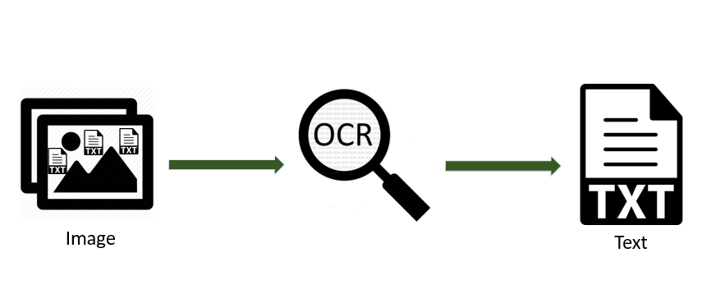

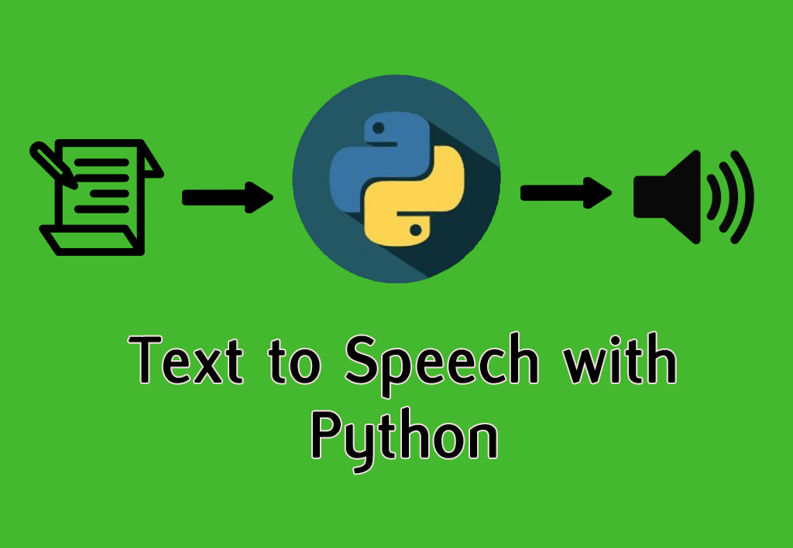

.

### Reporting

Reporting is a most important and underrated skill of a data analytics field. Because being a Data Analyst you should be good in easy and self-explanatory report because your model will be used by many stakeholders who are not from technical background.

1. High Level Design Document (HLD)
2. Low Level Design Document (LLD)
3. Architecture
4. Wireframe
5. Detailed Project Report
6. Power Point Presentation